-- EXERCISE 7

-- 1. List the names of the 5 youngest employees in the company.
SELECT F_NAME, L_NAME, AGE
FROM EMPLOYEE_DATA
ORDER BY AGE ASC
LIMIT 5;
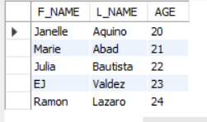

-- 2. Extract the next 5 entries starting with the 10 row.
SELECT *
FROM EMPLOYEE_DATA
LIMIT 9, 5;
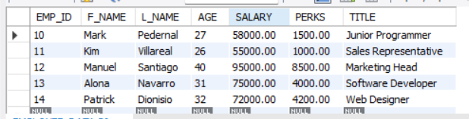

-- 3. Display the names and salary of the employee who draws the largest salary.
SELECT F_NAME, L_NAME, SALARY
FROM EMPLOYEE_DATA
ORDER BY SALARY DESC
LIMIT 1;
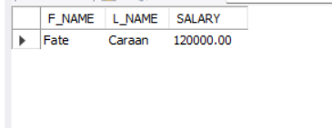

-- 4. What does the following statement display?
SELECT emp_id, age, perks
FROM employee_data
ORDER BY perks DESC
LIMIT 10;
-- IT DISPLAYS THE 10 EMPLOYEES WITH THE HIGHEST PERKS, SORTED FROM LARGEST TO SMALLEST PERKS.
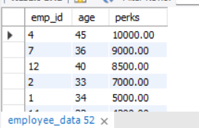

CREATE DATABASE IF NOT EXISTS EXERCISE7_DB;
USE EXERCISE7_DB;
CREATE TABLE EMPLOYEE_DATA (
EMP_ID INT AUTO_INCREMENT PRIMARY KEY,
F_NAME VARCHAR(50),
L_NAME VARCHAR(50),
AGE INT,
SALARY DECIMAL(10,2),
PERKS DECIMAL(10,2),
TITLE VARCHAR(100)
);
INSERT INTO EMPLOYEE_DATA (F_NAME, L_NAME, AGE, SALARY, PERKS, TITLE) VALUES
('Kishey', 'Gacute', 34, 80000, 5000, 'Programmer'),
('Kim', 'Ricaro', 33, 90000, 7000, 'Marketing Executive'),
('Trisha', 'Ogbac', 35, 85000, 4000, 'Sales Associate'),
('Recelle', 'Janda', 45, 100000, 10000, 'Senior Programmer'),
('Alessandra', 'Rivano', 29, 75000, 3000, 'Web Designer'),
('Jamaima', 'Rabulan', 25, 65000, 2500, 'Finance Assistant'),
('Fate', 'Caraan', 36, 120000, 9000, 'Marketing Manager'),
('Mariel', 'Cuenca', 28, 70000, 3500, 'HR Assistant'),
('Melody', 'Monreal', 30, 65000, 2000, 'Marketing Staff'),
('Mark', 'Pedernal', 27, 58000, 1500, 'Junior Programmer'),
('Kim', 'Villareal', 26, 55000, 1000, 'Sales Representative'),
('Manuel', 'Santiago', 40, 95000, 8500, 'Marketing Head'),
('Alona', 'Navarro', 31, 75000, 4000, 'Software Developer'),
('Patrick', 'Dionisio', 32, 72000, 4200, 'Web Designer'),
('Faye', 'Dimaculangan', 30, 77000, 3900, 'Programmer'),
('Ramon', 'Lazaro', 24, 50000, 1200, 'Intern'),
('Julia', 'Bautista', 22, 48000, 900, 'Trainee'),
('EJ', 'Valdez', 23, 49000, 1000, 'Office Assistant'),
('Marie', 'Abad', 21, 46000, 800, 'Receptionist'),
('Janelle', 'Aquino', 20, 45000, 500, 'Clerk'),
('Lance', 'Garcia', 25, 52000, 1100, 'Junior Web Designer');use students_db;

